

Project 2

Last 4 digit : 4767

CSCI 331 33

4/25/2018



create table owners(

owner_ID number not null,

owner_first varchar(25),

owner_last varchar(25),

owner_street varchar(30),

owner_city varchar(50),

owner_state varchar(2),

owner_zip varchar(10),

primary key (owner_id)

);

Table for dogs are imported.

create table owner_numbers(

number_id number not null,

owner_id number,

owner_number varchar(12),

primary key (number_id),

foreign key (owner_id) references owners(owner_id)

);

create table dog_photos(

photos_id number not null,

dog_id number not null,

photos varchar(70) not null,

primary key(photos_id ),

foreign key (dog_id) references dogs(dog_id)

);

create table registers(

register_number number not null,

dog_id number not null,

owner_id number not null,

register_date date not null,

own_till date not null,

primary key(register_number),

foreign key(dog_id) references dogs (dog_id),

foreign key(owner_id) references owners (owner_id)

);

create table tickets(

ticket_number number not null,

owner_id number not null,

dog_id number not null,

ticket_date date not null,

status1 varchar(1) not null,

primary key(ticket_number ),

foreign key(owner_id) references owners (owner_id),

foreign key(dog_id) references dogs (dog_id)

);

create table violations(

violation_number number not null,

violation_description varchar(100) not null,

fine varchar(10) not null,

primary key(violation_number)

);

create table ticket_violations(

ticket_violation_id number not null,

ticket_number number not null,

violation_number number not null,

primary key(ticket_violation_id),

foreign key(ticket_number) references tickets(ticket_number),

foreign key(violation_number) references violations(violation_number)

);

1. Identify dogs without violations in the last year. Display the owner name, dog name, breed and email. Use a nested select to answer this question.

select owner_First, owner_last, owner_email, dog_Name, breed

from dogs, owners

where (Dog_ID ,owner_id) in (

select registers.dog_id, registers.owner_id

from registers

where (registers.dog_id, registers.owner_id) not in (

select tickets.owner_id, tickets.dog_id

from tickets

where tickets.ticket_date >'1/1/17' ));

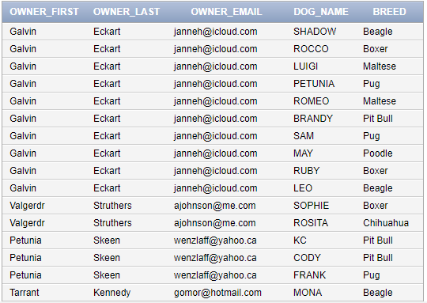

2. Identify zip codes without registered pit bulls now. Display the zip code.

Remove duplicate zip codes. Use a nested select to answer this question.

|  |  |
| --- | --- |
| select owner_zip  from owners  where owner_id not in (  select registers.owner_id  from registers  where registers.dog_id in (  select dogs.dog_id  from dogs  where breed = 'Pit Bull'  ))  group by owner_zip; |  |

3. Identify dogs without owners now. Display the dog name, gender, breed and age.Use a nested select to answer this question.

|  |  |
| --- | --- |
| select dog_name, gender, breed, TRUNC(months_between(sysdate,birthmonth)/12) year  from dogs  where dogs.dog_id not in (  select registers.dog_id  from registers  where registers.own_till is null  ); |  |

4. Identify current dog owners with a residence near Elmhurst. Display the owner name, dog name and breed

|  |  |
| --- | --- |
| select owner_first FirstName, owner_last LastName, dog_name DogName, breed  from dogs, owners  where (dogs.dog_id,owners.owner_id) in(  select registers.dog_id,registers.owner_id  from registers  where registers.own_till is null  ); |  |

5. Identify pictures of female poodles less than five years old. Display the dog name, age and all photos.

|  |  |
| --- | --- |
| select dogs.dog_name, TRUNC(months_between(sysdate,birthmonth)/12) year, dog_photos.photos  from dogs, dog_photos  where dogs.breed = 'Poodle' and  dogs.dog_id=dog_photos.dog_id  ; |  |

6. Identify dogs owned by Sally Smith with violations in the last year. Display the owner name, dog name, violation, date of violation and fine.

select owner_first firstname, owner_last lastname, dog_name dogname, ticket_date ticketdate, violation_description violations, to_char(fines, '$9,999.99') fines

from dogs, owners, tickets, violations, ticket_violations

where owners.owner_first='Sally' and

owners.owner_last='Smith'and

tickets.owner_id = owners.owner_id and

tickets.dog_id = dogs.dog_id and

tickets.ticket_number = ticket_violations.ticket_number and

ticket_violations.violation_Number = violations.violation_number

;

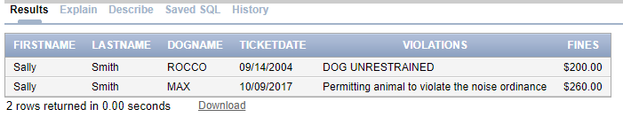

7. Identify the number of dogs by gender. Display two columns and one row for

each gender. The two output columns are gender and number of dogs with that

gender. Use a function to answer this question.

|  |  |
| --- | --- |
| select dogs.gender , count(*) Count  from dogs  group by gender; |  |

8. Identify zip codes with the most pit bulls. Display two columns and one row for each zip code. The two output columns are zip code and number of dogs in thatzip code. Display the zip code with the most pit bulls first. Use a function to answer this question.

|  |  |
| --- | --- |
| select owners.owner_zip ZipCode, count(owners.owner_zip) Number_Of_Pitbull  from dogs, owners  where dogs.breed = 'Pit Bull' and  (dogs.dog_id, owners.owner_id) in (  select registers.dog_id, registers.owner_id  from registers  where own_till is null  )  group by Owners.owner_zip  order by Owners.owner_zip desc  ; |  |

9. Identify the number of total fines by owner in the last two years. Display threecolumns and one row for each owner. The three columns are owner name, number of violations and total dollar amount of fines. Display owners with the most fines first. Use a function to answer this question.

|  |  |
| --- | --- |
| select (owners.owner_first || ' ' || owners.owner_last) as Name, count(ticket_violations.ticket_number) numberofviolations, to_char(sum(violations.fines), '$9,999.99') fines  from owners, violations, ticket_violations, tickets  where owners.owner_id = tickets.owner_id and  tickets.ticket_number in  ticket_violations.ticket_number and  ticket_violations.violation_number = violations.violation_number  group by owners.owner_first, owners.owner_last, ticket_violations.ticket_number  ; |  |

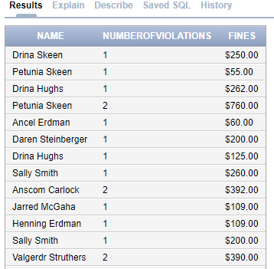

10. Increase all fines by 20%. Identify the SQL to perform this operation and the fine before and after this operation.

|  |
| --- |
| select violations.violation_description, to_char(violations.fines, '$9,999.99') fines,  to_char(violations.fines*1.2, '$9,999.99') raised20percents  from violations  ; |

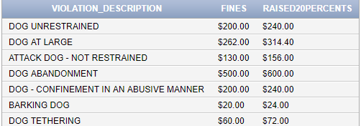

11.

Owners

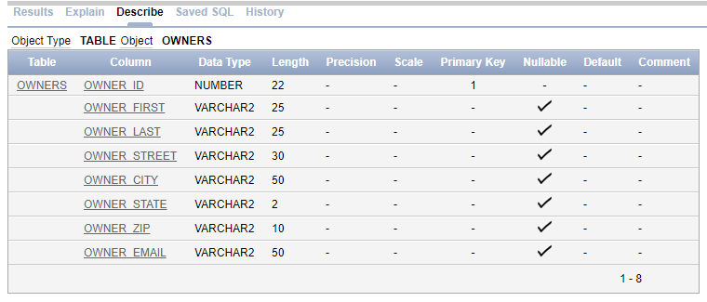

Owner_numbers

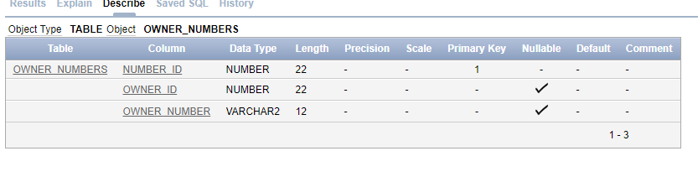

Dogs

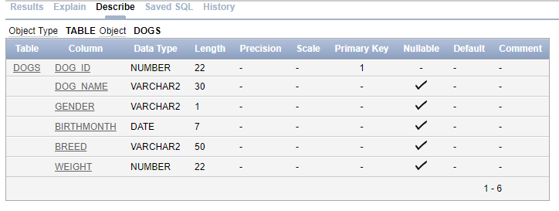

Dog_Photos

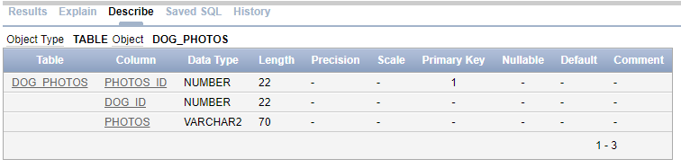

Registers

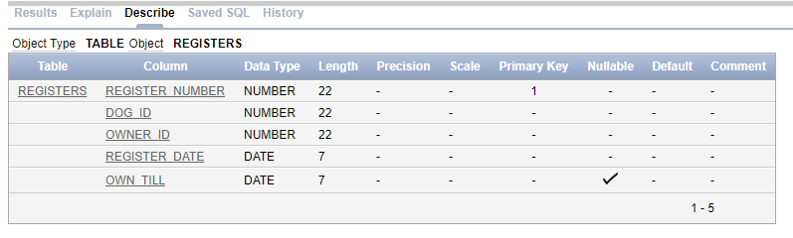

Tickets

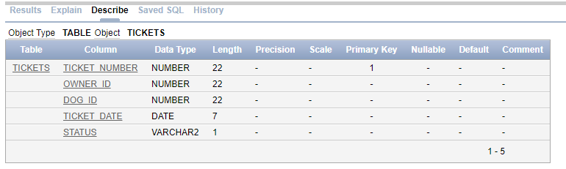

Violations

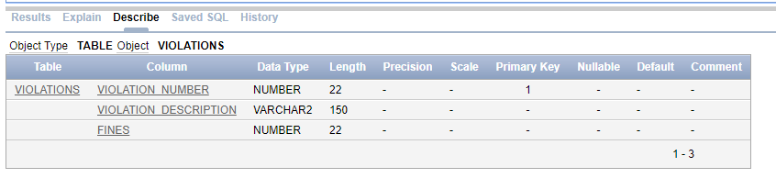

ticket_violations

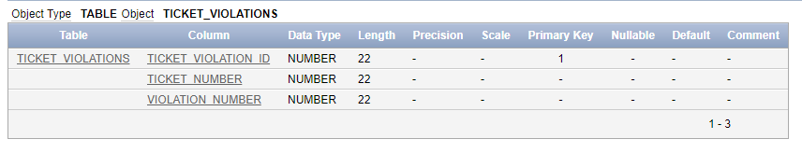

12.

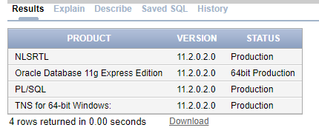

Multi Insert into Dog_Photos

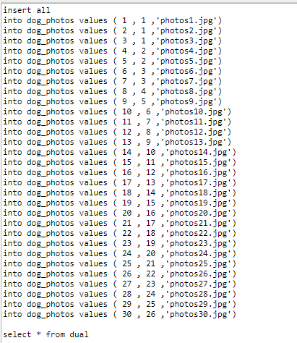

Update dogs

 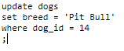

*Can’t locate most of input history due oricle having 200 history limit. This is most of my data, some are cut off due because it is too large. Most data were input by using (insert all … select * form dual).

Owners

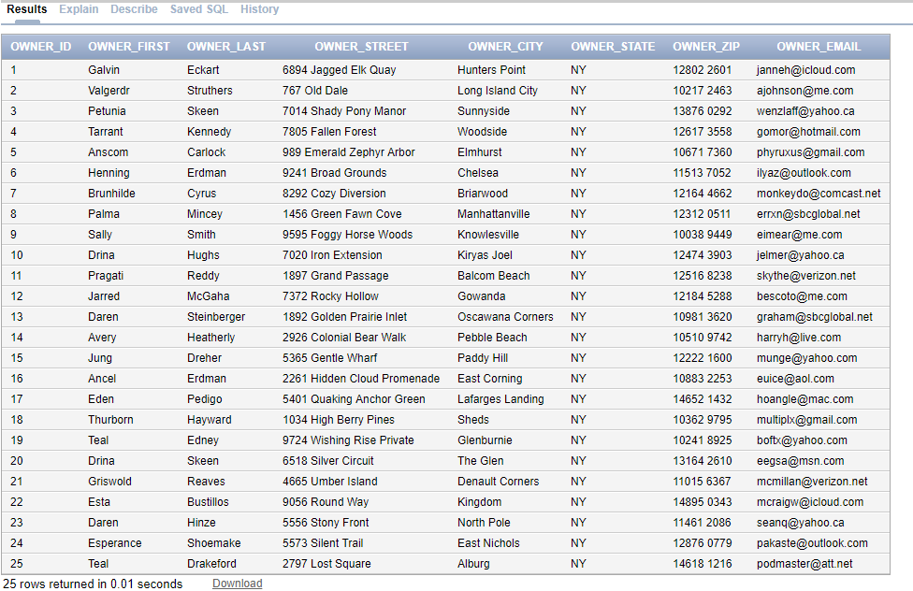

Owner_numbers

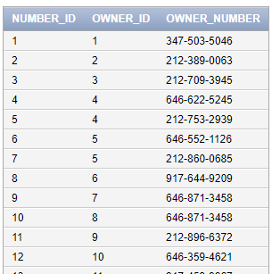

Dogs

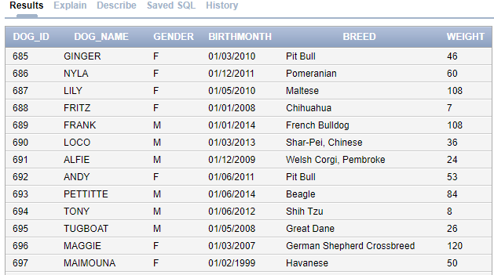

Dog_Photos

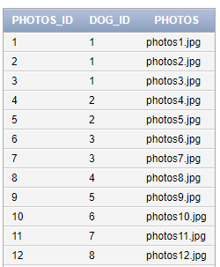

Registers

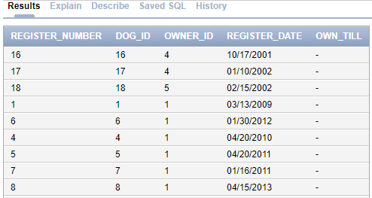

Tickets

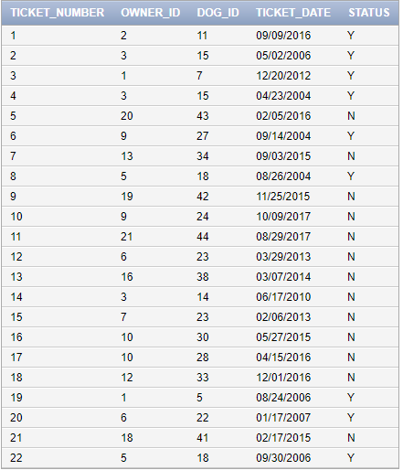

Violations

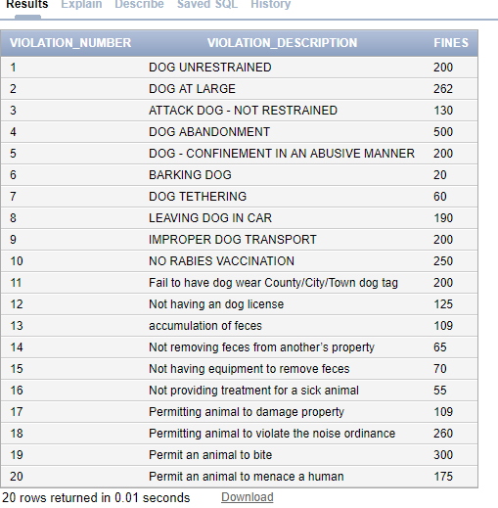

ticket_violations

